METAL MAGAZIN
http://metalmagazine.eu/bi/post/article/bienalsur-2017-from-buenos-aires-to-the-world

Bienalsur 2017 - From Buenos Aires to the worldWords by Arnau Salvadó
Share311

BIENALSUR 2017

FROM BUENOS AIRES TO THE WORLD

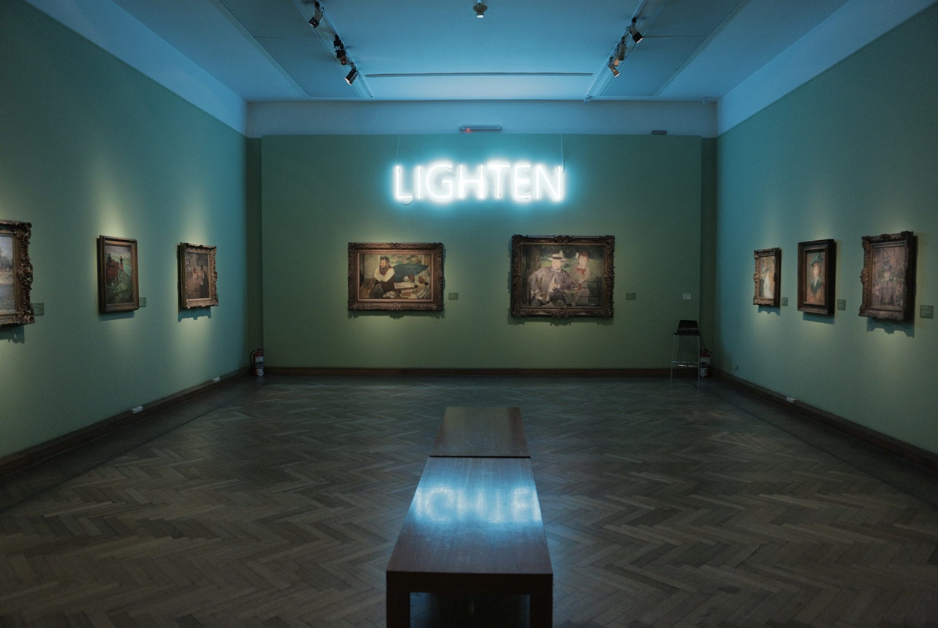
With the globalization of the art market, the number of art fairs, biennales, and pop-up events around them has boosted at an unstoppable pace. Some dare say that it’s already fatiguing and that, just like other economic markets, the fantasy-like bubble wrapping this glamorous business will end up exploding. So, what’s the point in organizing yet another one? Well, Bienalsur is the proof that there’s still space for surprising and innovative ideas. The reason? It’s just basically changed the rules of the game. Don’t miss the multiple exhibitions around the world until the end of December; at least one must be not-that-far from your home.
Organized by the Universidad Nacional de Tres de Febrero (UNTREF) in Buenos Aires (Argentina), more specifically by its rector and art passionate (and collector) Aníbal Jozami – and the event creative director Diana Wechsler –, the first edition of the International Biennial of Contemporary Art of South America – better known as Bienalsur – is conceived on the basis of a global network of institutional collaboration that erases distances and borders, as well as upholds singularity in diversity.
Following that philosophy, it has set a precedent that may change how we think of these events. Biennales were originally created to concentrate art from all around the globe in just one city, a worldwide known place of reference where all art lovers and professionals could meet. So what’s Bienalsur done so differently? It’s just basically destroyed this concept by atomizing the exhibitions and spreading them over thirty-two cities from sixteen different countries, from Bogotá to Madrid, to Ouidah, Paris and Tokyo.
In addition to starting what may become a kind of revolution, Bienalsur aims to shine a light on the importance of South America as a creative continent, full of nuances and richness. By making the world inevitably look and focus on what’s going on there – creating what could be called ‘the big South’, since most of the cities are from there, including Lima, Santiago de Chile, Rio de Janeiro, Montevideo and Quito, among others –, the team behind the biennale expects to and fights for the international recognition it deserves.
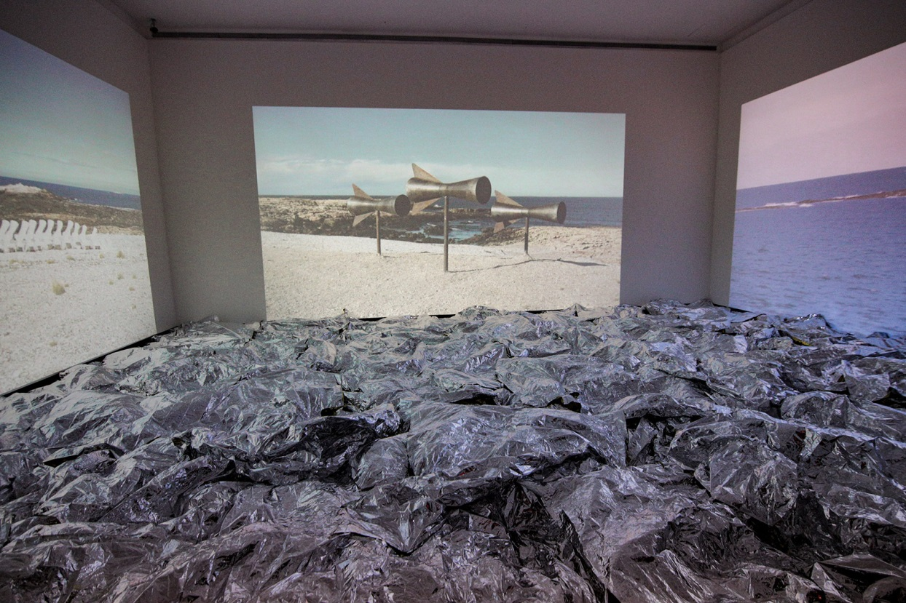
To do so, there are five main lines in which all exhibitions, artworks and events are classified: Actions and Interferences in the Public Space, Bienalsur’s Curatorship, Collection of Collections, Associated Projects, and Art in the Frontiers. The over two hundred and fifty artists handpicked from two international open calls display their works as either part of the biennale’s curatorship, or in public spaces, or in conversation with existing collections from museums and art institutions, although there are as well projects that decided to join forces with the initiative, and others that take place site-specifically in the frontiers between two countries (like the one in Cúcuta, a Colombian city ten minutes away from Venezuela, where Alex Brahim is highlighting the magnitude of the human and social tragedy that his neighbour country is suffering – and that a huge part of the world still ignores).
But it all starts in Buenos Aires, its birthplace. The organizers have thought of a clever (and very organized) way to connect all the cities – and spaces within the same city – participating in the biennale: cartography. From the starting km 0 at Hotel de Inmigrantes in the Argentinian capital to km 18.370 at Tokyo University of Arts, the wide range of exhibitions can be followed through this thread. But that arises a vital question: if biennales amalgamate all the artworks in one city, making it possible to see what’s going on all over the world without taking many flights, what’s the point of doing a delocalized biennale that seems unabated? Of course, critics will agree that it makes no sense.
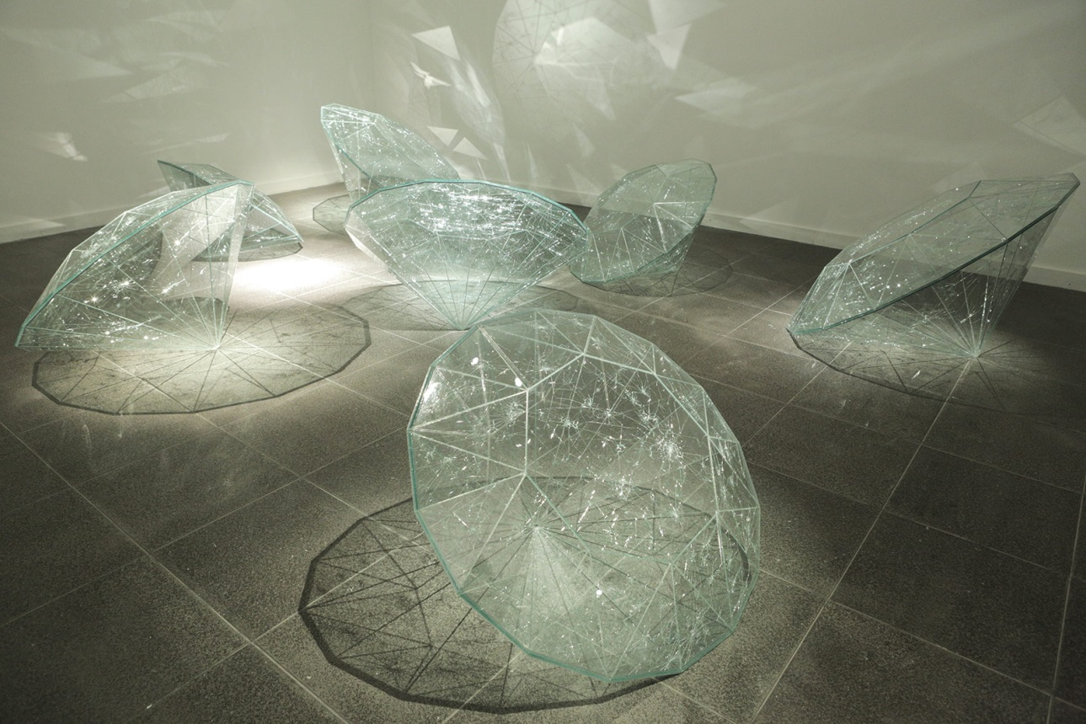
However, when analysing it more carefully, one sees that this is a double-edged sword: it is definitely impossible for a ‘normal’ human being to visit everything there is in Bienalsur. Yet, it is one of the most approachable big art events there is: by following the guidelines that huge multinationals are already applying, the ambitious event knows that the only way to succeed is to act locally and to pay attention to the people of each specific place. Instead of having an art fair in a posh space in London where celebrities go to show their wealthy status and the rich do business to get richer, Bienalsur establishes strong bonds in each city it sets foot in and has great social engagement – although, of course, we don’t forget that the art world is full of collectors and part of the social and economic elite.
That engagement to social issues can be seen, for example, in the abovementioned project by Alex Brahim in the frontier between Colombia and Venezuela in Cúcuta, where he’s selected loads of artists from the area to showcase their work, as well as programming child-focused activities and cinematographic cycles, or setting installations in the public space. It is also patent in the collective exhibition Pensamiento Salvaje (Wild Thought in English) at Casa Nacional del Bicentenario in Buenos Aires, where artists exhibit pieces exploring the relationship between humans and nature.
Among the pieces, there is one by Pedro Torres talking about the global warming and space colonization based on the Outer Space Treaty, that reflects on where the future will take us; there’s also a very shocking one, in which plants emit electronic sounds when touched. In that same exhibition, visitors can also enjoy artworks and installations including one consisting of big cracked glass sculptures resembling diamonds, projects about giving a meteor back to its natural place because of a tribe’s demands, or books in movements that resemble those of a bird or a butterfly.
Still in an environmentally conscious atmosphere, the exhibition held at Centro Cultural Kirchner showcases three site-specific commissioned pieces: a video by Angelika Markul reflecting on the unstoppable meltdown of glaciers, a highly aesthetic and moving five-screen projection by Charly Nijensohn, and an installation by Shirley Paes Leme composed by neon lights and a mirror-like floor that makes the visitor aware of how vital water is.
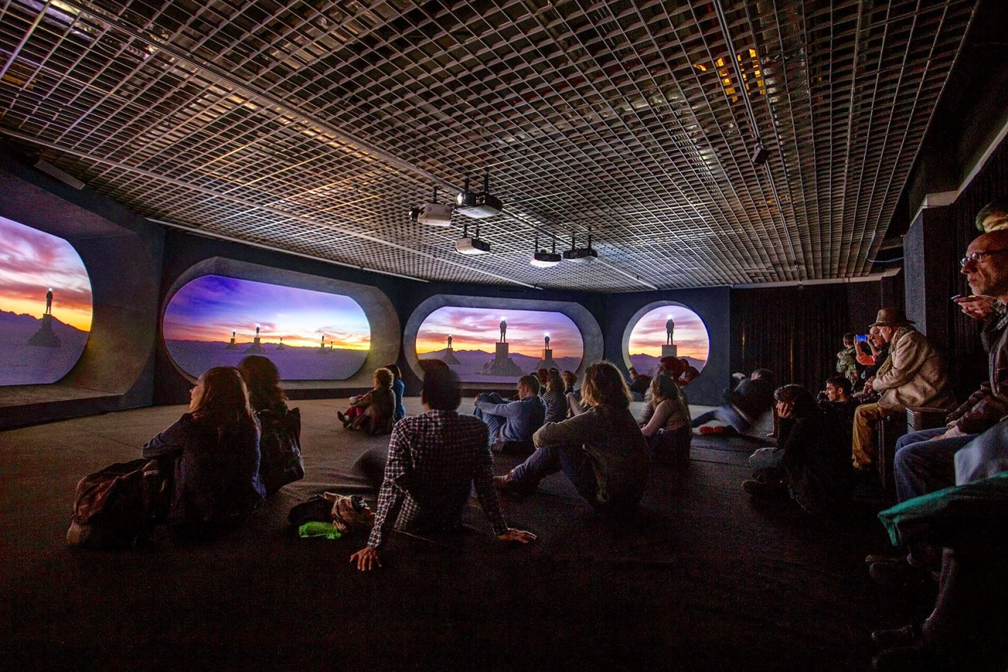
But humankind’s mistreatment towards nature doesn’t end here. It is also present at the former city zoo, now in transition to becoming an ecological space. The so-called EcoParque is now hosting an exhibition including pieces by artistic duo Dias and Riedweg, who explore the idea and dichotomy between two kinds of time – chronos and kairos – and how it affects both us, others and the environment, or an installation in which the visitor can literally hear the sounds of plants thanks to the work by Colectivo Electrobiota, among others.
Focusing on more local-focused issues – that, of course, affect the rest of the world – one can also see how important historical memory is to people. Argentinian citizens have fought and denounced how much has state terrorism affected society, and that is also reflected in the exhibition held at Centro Cultural de la Memoria Haroldo Conti, a former detention and torture space where more than five thousand civilians were killed by the military dictatorship and that has been reconverted into a cultural centre recently. Striking artworks by Brazilian Ivan Grilo – who also has a piece at the Museo Histórico Nacional related to the sad history of black people in the country –, or by Cristina Piffer, who has created a huge table with more than three hundred baptism documents of indigenous who were forced to ‘embrace’ Christianity as well as slavery, are only two examples of the moving collective show.
This consciousness regarding historical memory can also be seen at the facades of the Parque de la Memoria and the Centro Cultural Recoleta through the artwork Touch, by Regina Silveira, who’s intervened them with vinyl handprints with the intention to attract passer-by’s attention and colonize public space, reminding everyone on how important to the world is everyone’s imprint. And as well at MALBA (Museo de Arte Latinoamericano de Buenos Aires), where artist Alexander Apóstol has an exhibition in which, along with several departments of the Universidad Nacional Tres de Febrero, he goes back to the artistic-politic text titled Tucumán arde (translated Tucumán burns), a revolutionary document created collectively by artists and intellectuals in 1968.
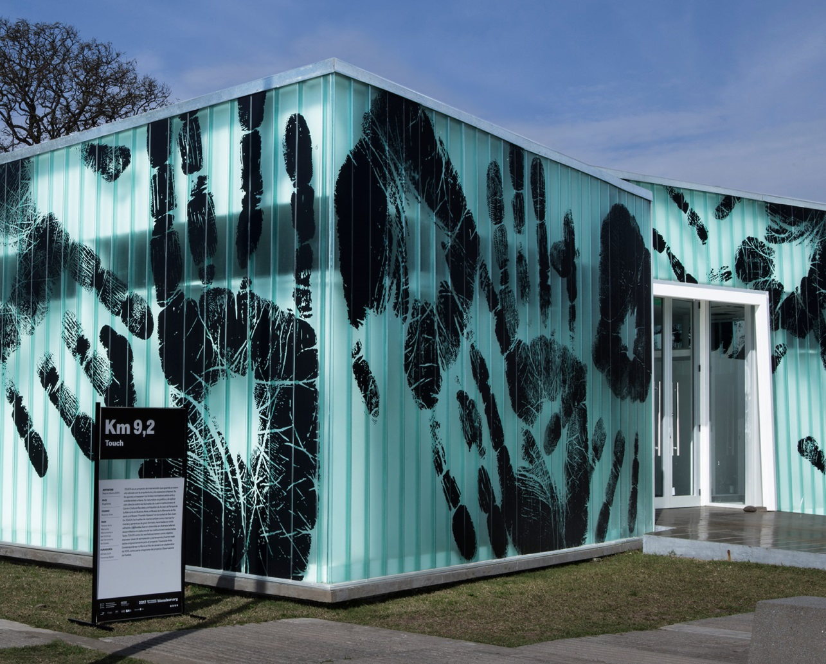
On another hand, there are also exhibitions less socially or politically driven. Three examples can be found at Museo Nacional de Bellas Artes: the first one combines the Argentinian museum’s collection with some pieces of Geneva’s Musée d’Art Moderne et Contemporain, making them dialogue and adding new meanings to the ones already existing. The second one is by Spanish abstract artist Joan Miró, whose works have been lent by Museo Reina Sofía in Madrid and the exhibition curated by its director, Manuel Borja-Villel.
The last one is called Mysteries, and it’s by Christian Boltanski, one of the biggest names participating in Bienalsur. In it, he’s done an installation in which the floor of a room is covered by silver plastics and on its walls visitors can see three screenings depicting the artist’s quest to communicate with whales. Actually, Boltanski’s contribution to the biennale doesn’t end up here. Alongside with Hans Ulrich Obrist, he’s also curated the exhibition Take Me (I’m Yours) at Museo Nacional de Arte Decorativo – a show that is also currently on view at Milan’s Hangar Bicocca. The idea is that people can go and take small artworks by different artists: from a stencil by Lawrence Weiner to candies staged by Félix González Torres, to bottles of wine or second-hand clothes.
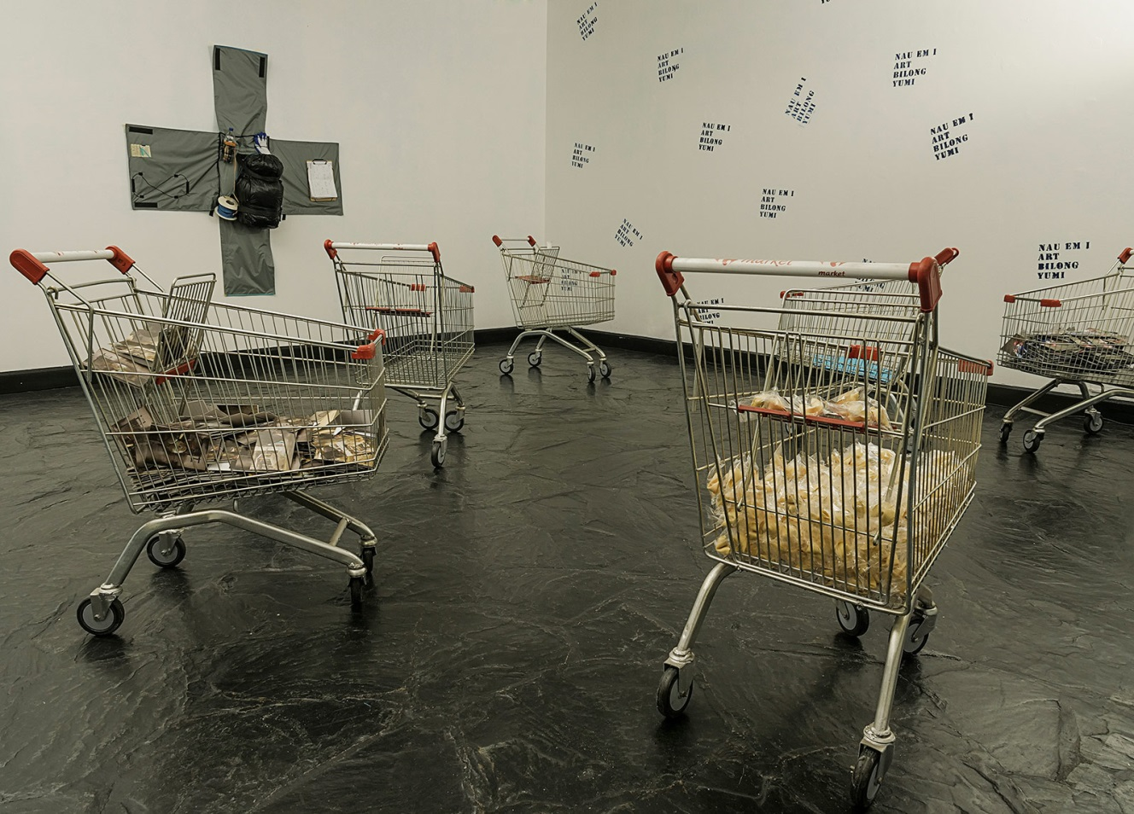
But if one place needs to be highlighted, that is of course the Hotel de Inmigrantes, the landmark and symbolic km 0. The complex of buildings, built during the early 20th century, was constructed with the intention to assist and receive the thousands of European immigrants escaping the Old continent to find a better life on the other side of the Atlantic, and on the other side of the hemisphere. It is now the Museo Nacional de la Inmigración and the Museo Nacional de la Tres de Febrero (the university museum). Especially for Bienalsur, the space has been ‘occupied’ by a wide range of exhibitions, interventions and actions, which go from big sculptures like the one by Iván Argote to site-specific installations like the one by Tatiana Trouvé. One of the most ambitious exhibitions of the space, Arte para pensar la nueva razón del mundo, is a collective show curated by Museo Reina Sofia’s team with the recently-acquired artworks of the Spanish institution, which includes pieces by Harun Farocki, Peter Friedl, Allan Sekula and Inés Djoujak, among others.
Nevertheless, as I’ve been highlighting since the beginning, one of the main reasons why Bienalsur is unique is its breaking DNA and atomization throughout the globe. So, in addition to Buenos Aires, we must also recommend a visit to Tigre, a town an hour away from the capital, whose museum and surroundings also exhibit some interesting pieces, like an installation by Leandro Erlich that makes the spectator become a jogger and run with a drumstick to play the art piece’s ‘secret’ tone. And that is, of course, if you happen to live in Argentina. But if you don’t, you only need to check what’s the nearest city or cultural centre to where you live, and book a flight to catch a glimpse of the magnificent, ambitious but strong biennale that will become a very relevant artistic agent in the years to come if it knows how to play its cards. For the moment, we know it’s playing an important role towards the development of today’s (and tomorrow’s) global art scene.
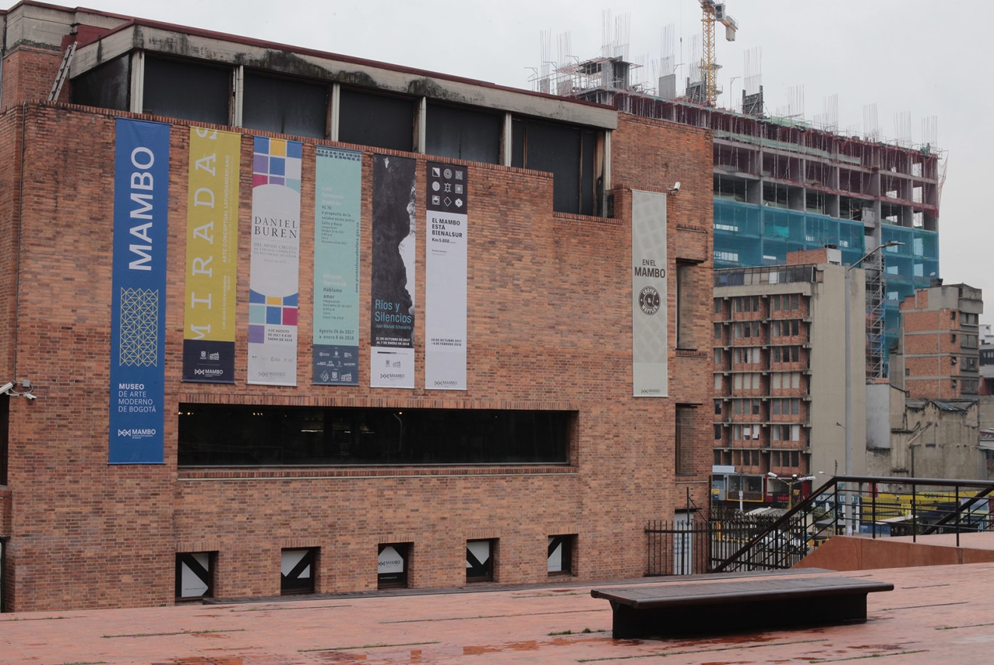
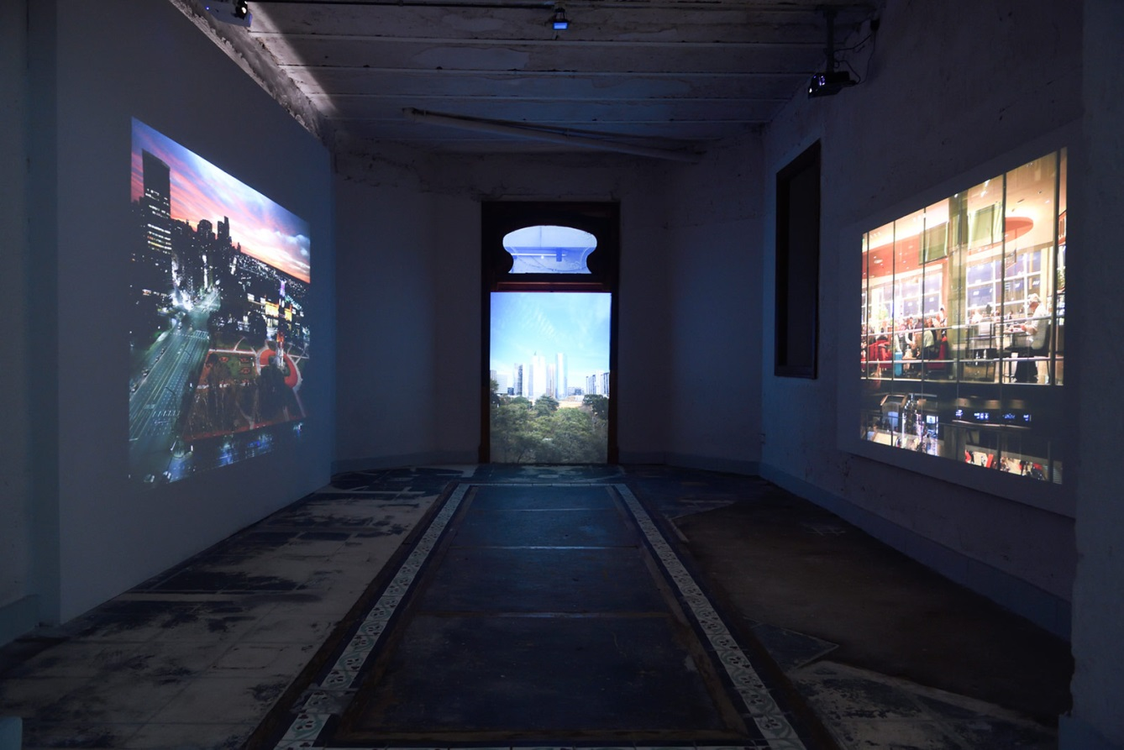
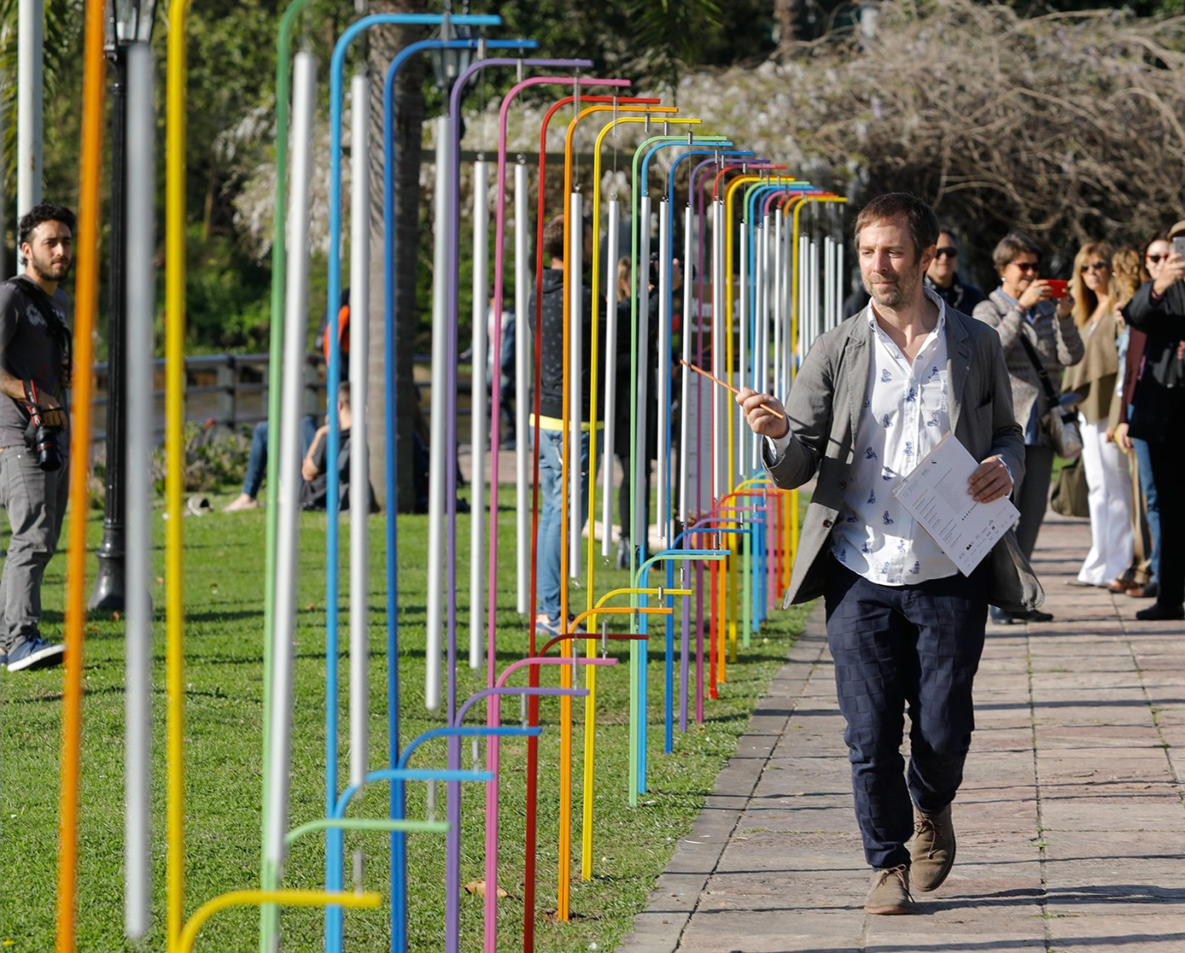
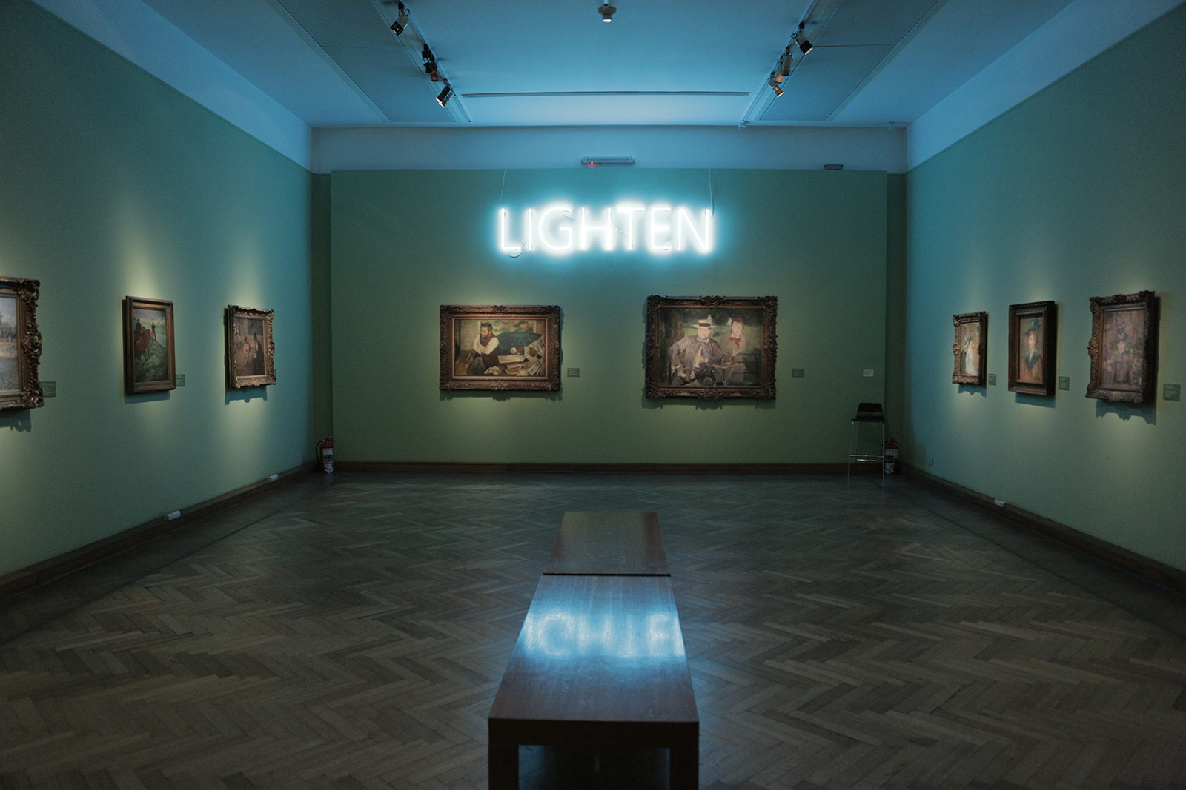
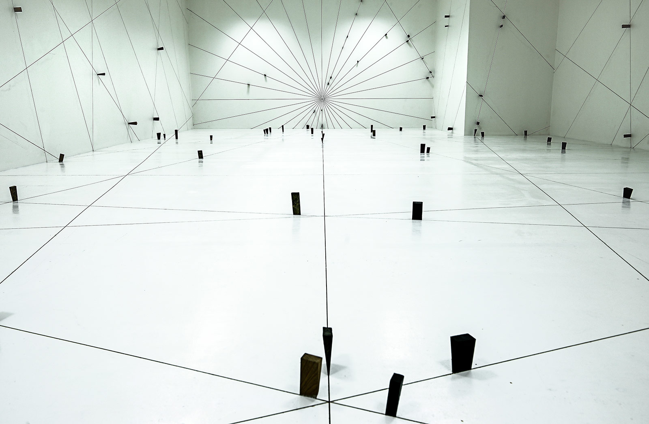
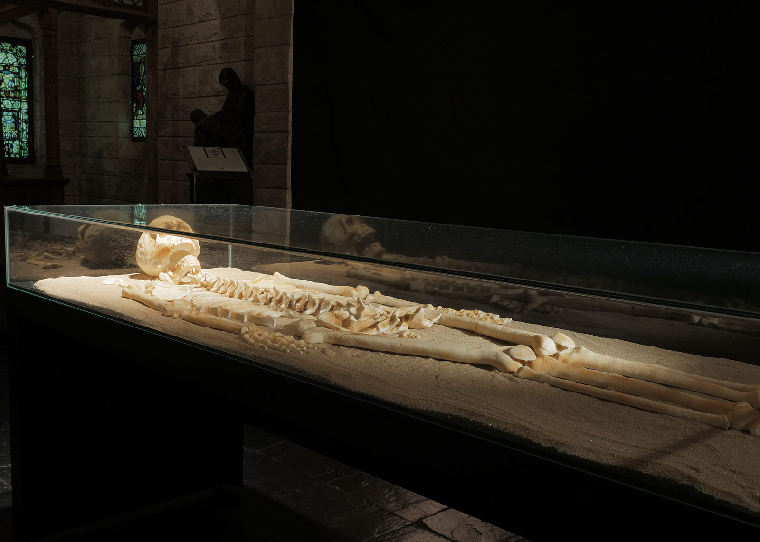
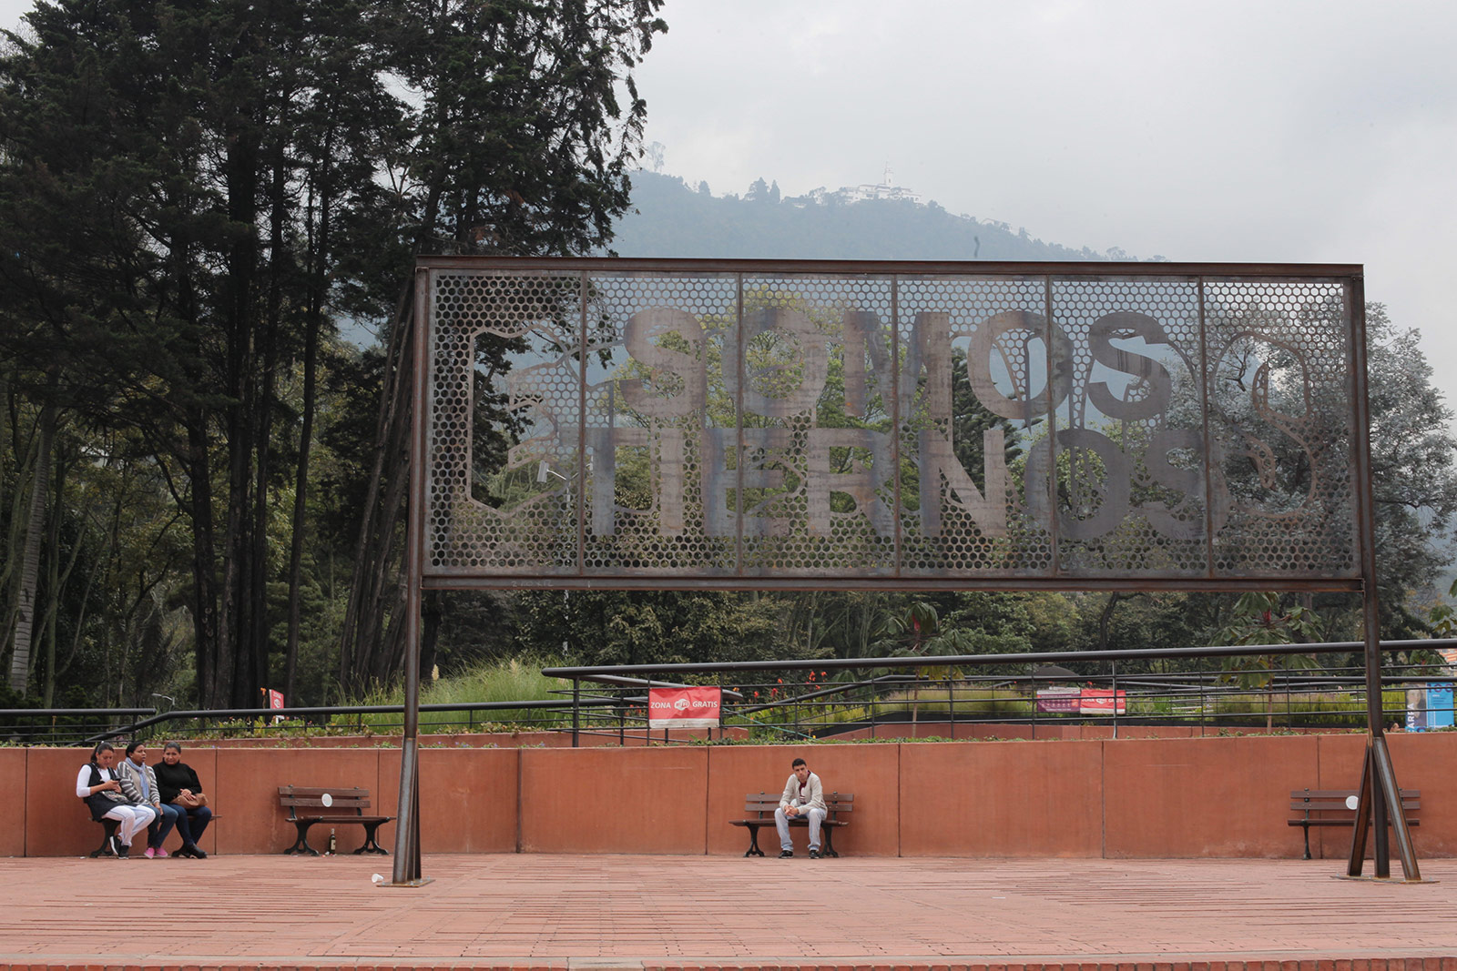
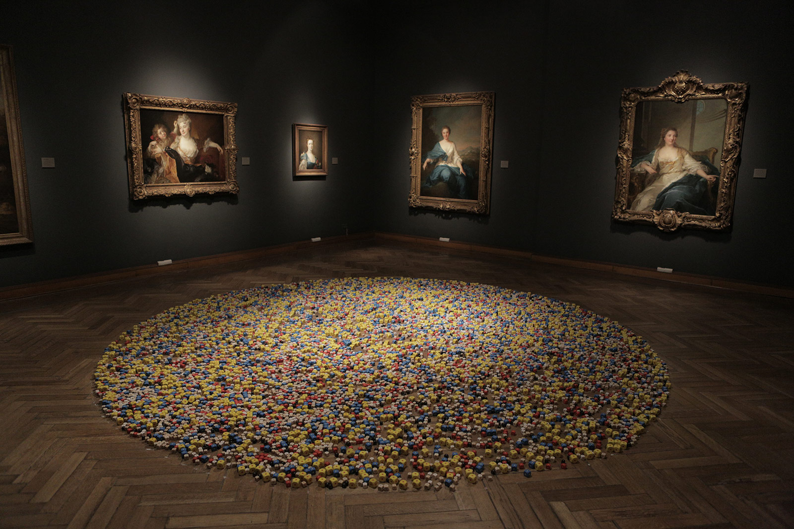

Words

Arnau Salvadó

